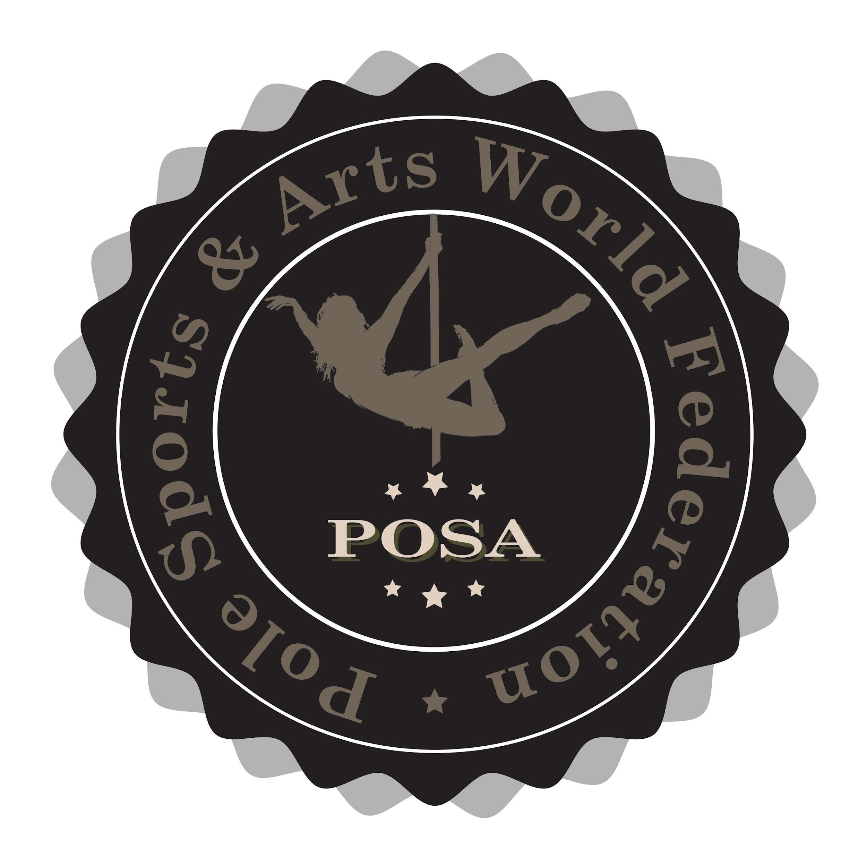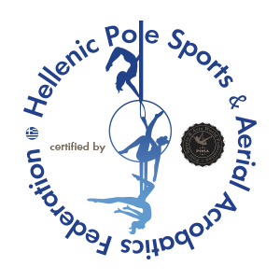

Parent Consent Form

HPSAF POSA GREECE NATIONAL / INTERNATIONAL POLE AND AERIAL CHAMPIONSHIP 2026

Name of Child ………………………………… Date of Birth ………………………...……………….……

Parent/ Guardian ………………………………………………………………………………………......
Address: ……………………………………………………………………………………...…………………….
………………………………………………………...……........................… Postcode ………………………
Mobile: …………………………………………………….. e-mail: ……………………………........................
Emergency contact details: (If different from above)
Name: ……………………………………………………………… Telephone no: ……………..…………
Relationship to child: ……………………………………………………………………………….................
CONSENT (please read carefully)
- I consent to my son/daughter participating in the HPSAF National International Pole & Aerial Sport and Art Championship 2026 on the ___________ 2026 at Dais Sport Center, located at Mesogion 151, Paradisos, 151 26 Marousi, Athens, Greece.

- All athletes participate in HPSAF competitions at their own risk and acknowledge that any injuries or accidents that occur are their responsibility. Therefore, all athletes must have their own medical insurance.

- HPSAF provides medical assistance in the event of an injury. The medical representative has the final authority to determine whether an athlete’s injury requires disqualification from participating or continuing in the competition.

- HPSAF is not responsible for any loss or damage to the belongings of athletes or officials.

- I understand that the HPSAF Pole& Aerial Sport and Art Championship includes photography and videography, and that my child will be photographed and recorded. I acknowledge that these images may be used for advertising and press purposes.

Signed …………………………………................ (Parent/ Guardian) Date: ……………………………

