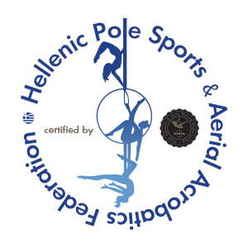

I Acknowledge that me and my coach have read, understood, and Agree to Posa World Federation and Hpsaf Posa Greece Rules and Regulations, I have read the Posa World Federation Code of Ethics and agree to abide by them. Failing to do so I shall be liable to disciplinary action.
My signature also gives Posa World Federation and Hpsaf Posa Greece permission to use my photos for promotional and or publication marketing.
My signature below acknowledges that I fully understand and agree with the terms and conditions stated above.

Athlete Name ……………………………………………………….
e-mail ……………………………………………………………………
Guardian Name ……………………………………………………… (if athlete is under 18years)
Date: ………………………………………….
Signature Athlete ………………………………………………….

